Part I Waveform

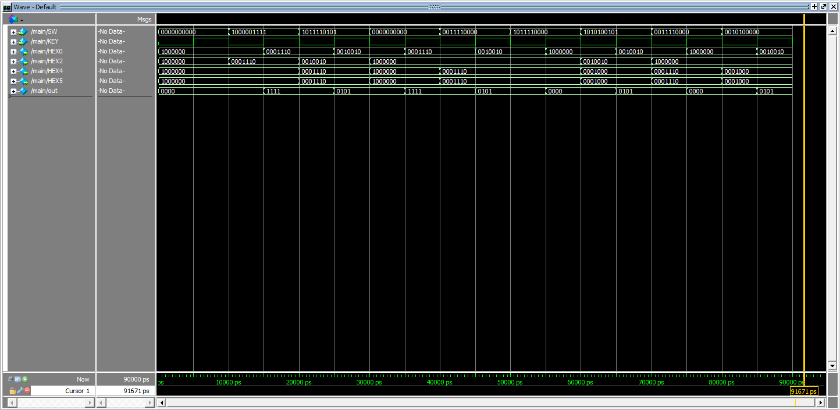

{Enable, Address (4 bit), Data (4bit)}

clk

Store 0101 into 1111

Read 1010

Read 1111

Store 0101 into 1010

Store 0000 into 1111

Read 1111

Read 0000

Store 1111 into 0000

Reset to 0

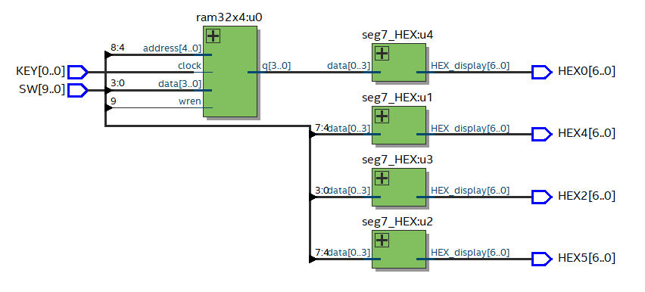Part I Schematic

Part II Schematic

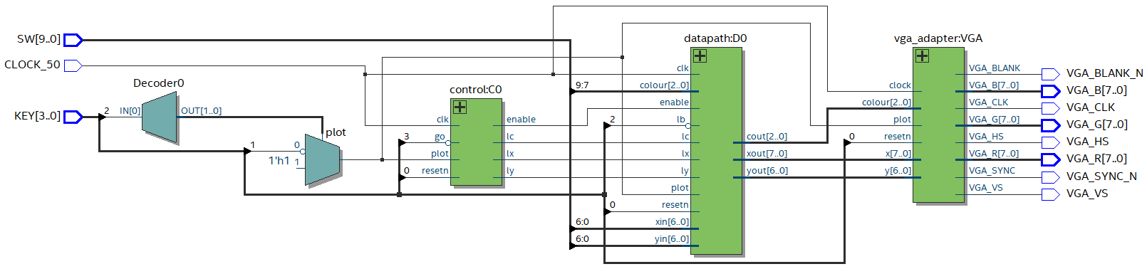

Part II State Diagram

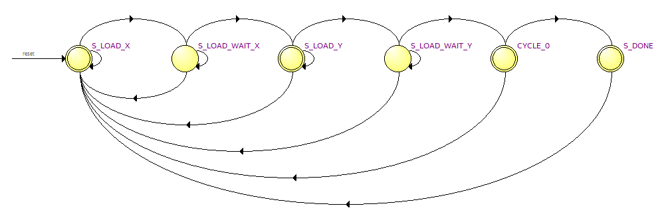

RESET

!go

RESET

RESET

RESET

RESET

!go

!go

go

go

go

!go

go

Part II Controller Waveform

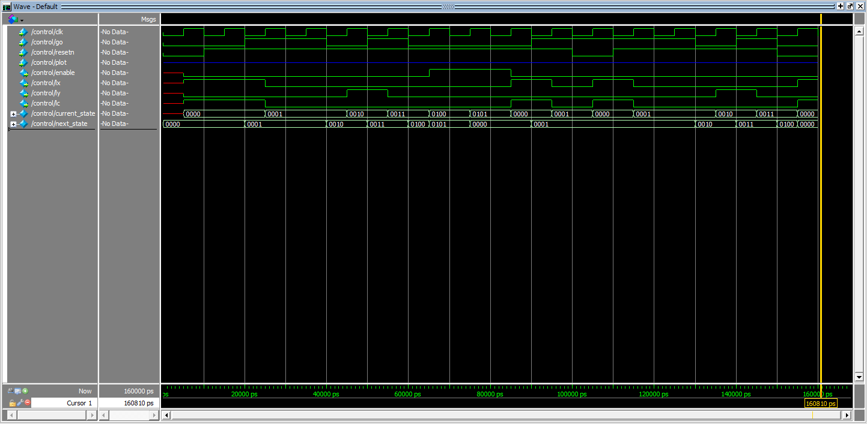

Stay at Y_load_Wait

Stay at X_load_Wait

Reset

Go to Y_load

Go to X_load_Wait

Reset

Go to X_load

Go to X_load_Wait

Go to Done

Go to Cycle State

Stay at Y_load_Wait

Go to Y_load

Stay at X_load_Wait

Go to X_load_Wait

Stay at X_load

Reset

Part II Datapath Waveform

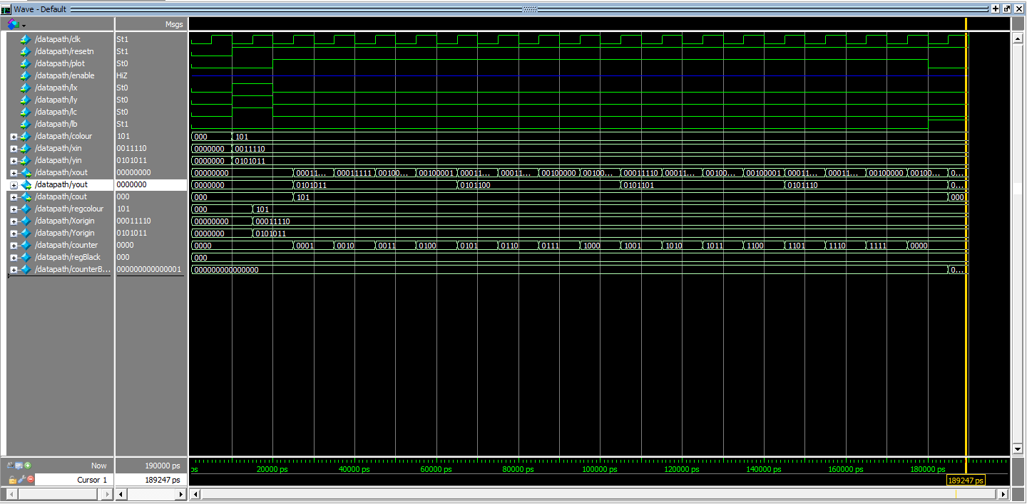

Reset

Set clr, x, y

Reset

Display

Xout changes, as well as Yout, making the square 4 by 4

Part III – Direction Vector State Diagram (refer to Part II for FSM Controller & Datapath)

*Similarly for Yin

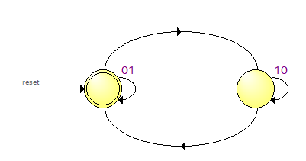

RESET

Xin > 7’d0

Xin == 7’d0

Xin == 7’d126

Xin < 7’d126

Part III Direction Vector Waveform

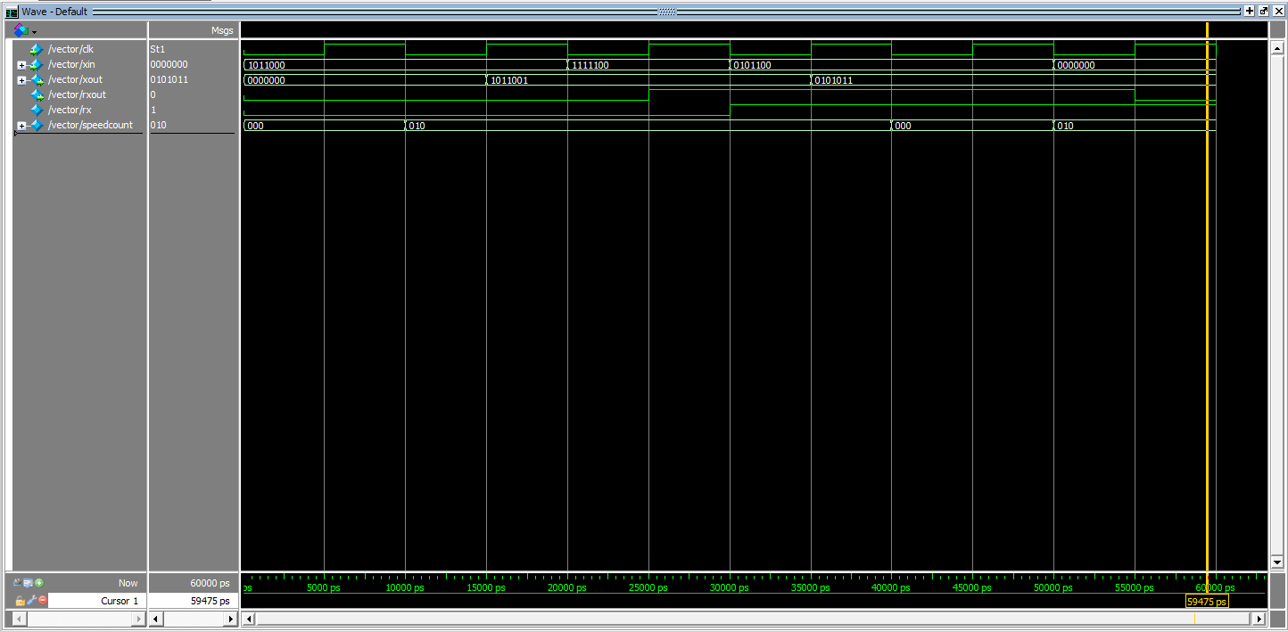

Xin Min, so Rx = 0 (direction change)

Speedcount not met, Xout remains constant

Speedcount met, Xout = Xin - 1

Xin Max, so Rx = 1 (direction change)

Speedcount met, Xout = Xin + 1

Speedcount not met, Xout remains constant